Name

Mathematics Stage 4
Factorising Expressions

Book 5 |  | Version: 260930  Feedback:  https://MrDingMaths.com
Contents
Syllabus Content 2
Factorising 1 3
Factorising 2 6
Factorising 3 10

Syllabus Content
MA4-ALG-C-01 generalises number properties to operate with algebraic expressions including expansion and factorisation
Factorise algebraic expressions by identifying numerical and algebraic factors
- Identify and list factors of a single term
- Factorise algebraic expressions using knowledge of factors and finding the highest common numerical factor (HCF)
- Factorise algebraic expressions using knowledge of factors by finding a common algebraic factor, including expressions involving more than 2 terms, and verify the result by expansion

Factorising 1

- Review
- Expand brackets
- $3\left(2x+5\right)$ | - $4\left(x+3\right)$ | - $5\left(2y-1\right)$ | - $2\left(3a+4\right)$

- Simplify terms by dividing by a variable
- $\frac{6x}{3}$ | - $\frac{15x}{5}$ | - $\frac{8y}{2}$ | - $\frac{10a}{5}$
- $\frac{18b}{6}$ | - $\frac{21c}{3}$ | - $\frac{14x}{2}$ | - $\frac{12m}{6}$

- Simplify terms by dividing by a variable
- $\frac{6x}{x}$ | - $\frac{5y}{y}$ | - $\frac{x^{2}}{x}$ | - $\frac{10x}{5x}$
- $\frac{18b}{6b}$ | - $\frac{21c}{3c}$ | - $\frac{14x^{2}}{2x}$ | - $\frac{12m}{6m}$

- Factorising
Factorising is the inverse of expanding.
Expanding

$$3\left(2x+5\right)=6x+15$$

Factorising

To factorise, divide each term by the term outside the brackets.
Put the results inside the brackets.

- Example Factorise, given the factor
Factorise:
$8y+12=4$(…………)  $$=4\left(\frac{8y}{4}+\frac{12}{4}\right)$$  $$=4\left(2y+3\right)$$ | $10a-15=5($…………)  $$=5\left(\frac{10a}{5}-\frac{15}{5}\right)$$  $$=5\left(2a-3\right)$$

- Guided Practice
Factorise
- $6x+9$  $=3$(…………) | - $12y+8$  $=4$(…………)
- $10a-5$  $=5$(…………) | - $14+7b$  $=7$(…………)
- $2xy+5x$  $=x$(…………) | - $18x^{2}-12x$  $=6x$(…………)

- Key Ideas
- Factorising is the ………………… of expanding.
- To find what goes inside the brackets, ………………… each term on the inside by the term outside the brackets.
- We can check our answer by …………… our result and confirming we get the original expression.

Foundation
- Factorise:
- $4x+6$  $=2$(…………)  $$2\left(2x + 3\right)$$ | - $9y+12$  $=3$(…………)  $$3\left(3y + 4\right)$$ | - $5a+10$  $=5$(…………)  $$5\left(a + 2\right)$$
- $8+12b$  $=4$(…………)  $$4\left(2 + 3b\right)$$ | - $7x+21$  $=7$(…………)  $$7\left(x + 3\right)$$ | - $16y+24$  $=8$(…………)  $$8\left(2y + 3\right)$$
- $6x-9$  $=3$(…………)  $$3\left(2x - 3\right)$$ | - $8y-12$  $=4$(…………)  $$4\left(2y - 3\right)$$ | - $15a-10$  $=5$(…………)  $$5\left(3a - 2\right)$$
- $20-14b$  $=2$(…………)  $$2\left(10 - 7b\right)$$ | - $9x-27$  $=9$(…………)  $$9\left(x - 3\right)$$ | - $24y-16$  $=8$(…………)  $$8\left(3y - 2\right)$$
- $6x+9y+12$  $=3$(………………)  $$3\left(2x + 3y + 4\right)$$ | - $8a-12b+4$  $=4$(………………)  $$4\left(2a - 3b + 1\right)$$ | - $10p+15q-20$  $=5$(…………………)  $$5(2p + 3q - 4)$$

- Factorise:
- $6x+xy$  $=x$(…………)  $$x\left(6 + y\right)$$ | - $y²-12y$  $=y$(…………)  $$y\left(y - 12\right)$$ | - $6ay+3a$  $=3a$(…………)  $$3a\left(2y + 1\right)$$
- $6x²+9x$  $=3x$(…………)  $$3x\left(2x + 3\right)$$ | - $8y²-12y$  $=4y$(…………)  $$4y\left(2y - 3\right)$$ | - $10a²+15a$  $=5a$(…………)  $$5a\left(2a + 3\right)$$

- In senior years you may need to factor out unusual terms.
- $6x+7y$  $=5$(…………)  $$5\left(\frac{6x}{5}+\frac{7y}{5}\right)$$ | - $y-12$  $=$ $\frac{1}{2}$(…………)  $$\frac{1}{2}\left(2y - 24\right)$$ | - $πx+3$  $=π$(…………)  $$π\left(x +\frac{3}{π}\right)$$

Factorising 2

- Review
- Identify highest common factor
- 6 and 9 | - 8 and 10 | - 15 and 20 | - 12 and 15
- 8, 6, and 10 | - 9, 12, and 6 | - 3 and 7 | - 4 and 8
- $18x$ and 24 | - $15y$ and 12 | - $16a$ and $12b$ | - $5x$ and 15
- 20 and $35a$ | - 24y and 36 | - $14x$ and $28y$ | - $9a$ and 15

- Factorise an expression, given the factor
- $6x+15=3$(…………) | - $4y+12=4$(…………) | - $10a+15=5($………)

- Factorising
To factorise:
- Identify the highest common factor (HCF) of the terms. Place it outside brackets.
- Divide each term by the HCF. Put the results inside the brackets.

- Example Factorise expressions (numerical HCF)
Factorise
$$15a+10$$  1. $5( )$  2. $5(3a+2)$ | We placed 5 outside the brackets because it is the …………………… ……………… ……………… of $15a$ and $10$.  The inside is $3a+2$ because we ……………… $15a$ and $10$  by 5.
$4a-12b$  1. $4\left( \right)$  2. $4(a-3b)$ | If we wrote: $4a-12b=2(2a-6b)$, this is not fully factorised because …………………………………………………………

- Guided Practice
Factorise
- $5x+15$ | - $8y+12$
- $14y-21$ | - $12x+18y$
- $15+9b$ | - $6x+9y+12$

- Key Ideas
- To factorise an expression:
  - Identify the …………………… …………………… …………………… of all terms.
  - Write the HCF ……………… the brackets.
  - ……………… each term by the HCF.
  - Write the results ………………… the brackets.
- We can check our answer by …………… our result and confirming we get the original expression.

Foundation
- Factorise the following.
- $3x+6$  $=3( )$  $$3\left(x+2\right)$$ | - $8x+40$  $=8( )$  $$8(x+5)$$ | - $15x-35$  $$5\left(3x-7\right)$$ | - $5j-20$  $$5\left(j-4\right)$$
- $9b-15$  $3\left(3b-5\right)$ | - $12+16f$  $4\left(3+4f\right)$ | - $5d-30$  $5\left(d-6\right)$ | - $48+12w$  $12\left(4+w\right)$
- $4x+6$  $$2(2x+3)$$ | - $9y+12$  $$3\left(3y+4\right)$$ | - $10a-15$  $5\left(2a-3\right)$ | - $14x-21$  $7\left(2x-3\right)$
- $18-27a$  $$9\left(2-3a\right)$$ | - $20b+15$  $5(4b+3)$ | - $14x-21y+7$  $7\left(2x-3y+1\right)$ | - $8a-12b+4$  $$4\left(2a-3b+1\right)$$

- Factorise these expressions, if possible.
- $30x+18$  $6\left(5x+3\right)$ | - $30x-18$  $6\left(5x-3\right)$ | - $30x-19$  can’t factorise | - $30x-20$  $10\left(3x-2\right)$
- $30x+20$  $10\left(3x+2\right)$ | - $35x+21$  $7\left(5x+3\right)$ | - $30x+18$  $6\left(5x+3\right)$ | - $27x+18$  $9\left(3x+2\right)$
- $18x+18$  $18\left(x+1\right)$ | - $9x+18$  $9\left(x+2\right)$ | - $9x+19$  can’t factorise | - $19x+19$  $19\left(x+1\right)$

- Fill in the blanks.
$12$ | 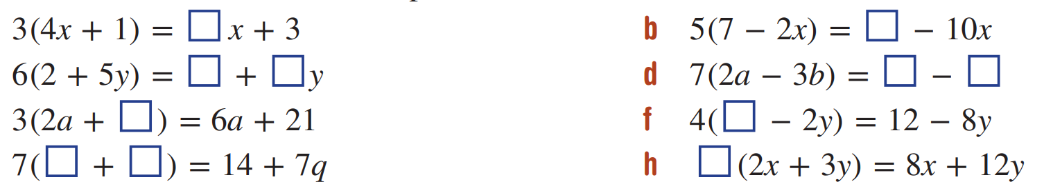  $$35$$
$12 , 30$ | $14a , 21b$
$7$ | $3$
$2 , q$ | $4$

Development
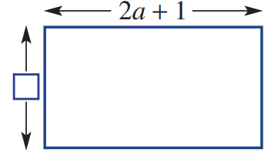
- The area of the rectangle is $10a+5$.
One side’s measurement is unknown.
  - What is the value of the unknown measurement?

5
  - Write an expression for the perimeter of the rectangle.

$4a+12$
- Match the shapes with the expressions that show their perimeters.
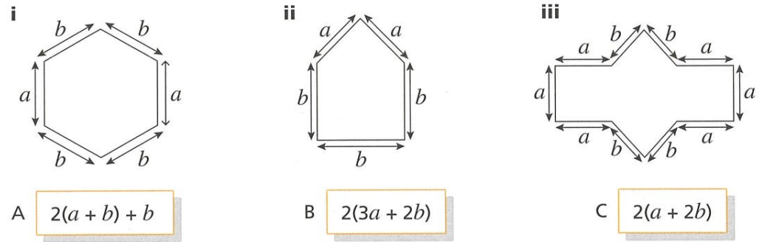

i-c, ii-A, iii-B

- There are 6 boxes of Smarties and 42 loose Smarties that are not in boxes.
  - Write an expression for the total smarties.

$6x+42$
  - Factorise the expression in part a.

$6\left(x+7\right)$
  - If the smarties are to be shared amongst 6 people, write an expression for the number of Smarties each person receives.

$x+7$
  - If the smarties are to be shared amongst 3 people, write an expression for the number of Smarties each person receives.

$2x+14$

Factorising 3

- Review
- Identify highest common factor
- $7x$ and $13x$ | - $25a$ and $15a$ | - $9a$ and $27ab$ | - $6xy$ and $12x$
- $2xy$ and $8xy$ | - $22xy$ and $44xy$ | - $3xr$ and $8r^{2}$ | - $7a$ and $21a^{2}$
- $ab$ and $a^{2}b$ | - $3p^{2}$ and $9pq^{2}$ | - $12qr$ and $8r^{2}$ | - $5x$ and 15

- Factorise expressions given algebraic factor
- $xy+5x$  $=x$(……………) | - $xy+6y^{2}$  $=y$(………...…) | - $15xy+10zy$  $=5y($……………)

- Factorise expressions by first finding the numerical HCF
- $2x+6$ | - $20+5x$ | - $12x+20y^{2}$

- Factorising
To factorise:
- Identify the highest common factor (HCF) of the terms. Place it outside brackets.
- Divide each term by the HCF. Put the results inside the brackets.

- Example Factorise expressions (algebraic HCF)
Factorise
$ab-5b$  1. $=b( )$  2. $=b(a-5)$ | $8xy+12y$  1. $=4y( )$  2. $=4y\left(2x+3\right)$ | $10a^{2}-15a$  1. $=5a( )$  2. $=5a\left(2a-3\right)$

- Guided Practice
Factorise
- $xk+xc$ | - $x^{2}+3x$
- $x^{2}-3x$ | - $6xb+8b$
- $3ab-5b$ | - $4xy^{2}-6y^{2}$

- Key Ideas
- To find the highest common factor of two algebraic terms:
  - Identify the highest ……………… that divides into both terms evenly.
  - Identify the variable, and its p………… that is common to both terms.
- We can check our answer by …………… our result and confirming we get the original expression.

Foundation
- Complete the factorisation.
- $2x+2$  $=2( )$  $2\left(x+1\right)$ | - $5x+15$  $=5( )$  $5\left(x+3\right)$ | - $x^{2}+x$  $=x( )$  $x\left(x+1\right)$
- $3x-6$  $=3( )$  $3\left(x-2\right)$ | - $x^{3}-x^{2}$  $=x^{2}( )$  $x^{2}\left(x-1\right)$ | - $8x-4x^{2}$  $=4x( )$  $4x\left(2-x\right)$
- $8y^{2}-12y$  $=4y( )$  $4y\left(2y-3\right)$ | - $12d+9dz$  $=3d( )$  $3d\left(4+3z\right)$ | - ${15x}^{3}+9x^{2}$  $={3x}^{2}( )$  $3x^{2}\left(5x+3\right)$

- Factorise these expressions.
- $6x+8$  $2\left(3x+4\right)$ | - $6x-8$  $2\left(3x-4\right)$ | - $12x-16$  $4\left(3x-4\right)$ | - $18x-24$  $6\left(3x-4\right)$
- $9x-12$  $3\left(3x-4\right)$ | - $12-9x$  $3\left(4-3x\right)$ | - $12x-9$  $3\left(4x-3\right)$ | - $60x-45$  $15\left(4x-3\right)$
- $20x-15$  $5\left(4x-3\right)$ | - $20x^{2}-15x$  $5x\left(4x-3\right)$ | - $20xy-15y$  $5y\left(4x-3\right)$ | - $20xy-15x$  $5x(4y-3)$
- $20-15x$  $5\left(4-3x\right)$ | - $21-15x$  $3\left(7-5x\right)$ | - $21x-15xy$  $3x\left(7-5y\right)$ | - $22x-15xy$  $x\left(22-15y\right)$

- Factorise the following.
- $x^{2}+2x$  $x\left(x+2\right)$ | - $a^{2}-4a$  $a\left(a-4\right)$ | - $y^{2}-7y$  $y\left(y-7\right)$
- $x-x^{2}$  $x\left(1-x\right)$ | - $3p^{2}+3p$  $3p\left(p+1\right)$ | - $8x-8x^{2}$  $8x\left(1-x\right)$
- $4b^{2}+12b$  $4b\left(b+3\right)$ | - $6y-10y^{2}$  $2y\left(3-5y\right)$ | - $12a-15a^{2}$  $3a\left(4-5a\right)$
- $9m+18m^{2}$  $9m\left(1+2m\right)$ | - $16xy-48x^{2}$  $16x\left(y-3x\right)$ | - $7xy-28ab^{2}$  $7\left(xy-4ab^{2}\right)$

Development
- Factorise the following.
- $10cn+12n$  $2n\left(5c+6\right)$ | - $24y+8ry$  $8y\left(3+r\right)$ | - $14jn+10n$  $2n\left(7j+5\right)$
- $24g+20gj$  $4g\left(6+5j\right)$ | - $10h+4z$  $2\left(5h+2z\right)$ | - $30u-20n$  $10\left(3u-2n\right)$
- $40y+56ay$  $8y\left(5+7a\right)$ | - $12d+9dz$  $3d\left(4+3z\right)$ | - $21hm-9mx$  $3m\left(7h-3x\right)$
- $49u-21bu$  $7u\left(7-3b\right)$ | - $28u-42bu$  $7u\left(4-6b\right)$ | - $21p-6c$  $3\left(7p-2c\right)$

- Fill in the table.
Expanded | Factorised |  | Expanded | Factorised
$$3p+15$$ | $3\left(p+5\right)$ |  | $6p^{2}-10p$ | $$2p(3p-5)$$
$3p+18$ | $$3(p+6)$$ |  | $$6p^{2}-10$$ | $2\left(3p^{2}-5\right)$
$$6p+18$$ | $6\left(p+3\right)$ |  | $$6-10p^{2}$$ | $2\left(3-5p^{2}\right)$
$$6p+15$$ | $3\left(2p+5\right)$ |  | $-6+10p^{2}$ | $$-2(3-5p^{2})$$
$6p+10$ | $$2(3p+5)$$ |  | $$-6+12p^{2}$$ | $6\left(-1+2p^{2}\right)$
$$6p-10$$ | $2\left(3p-5\right)$ |  | $$-6+11p^{2}$$ | can’t factorise

- Read the example carefully and answer the questions.
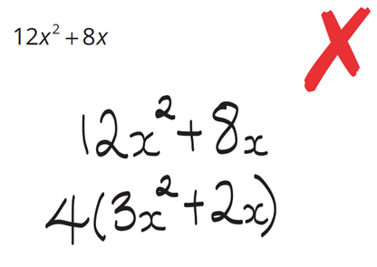  Caroline’s work: | Why is Caroline’s expression not factored completely?  $3x^{2}+2x$ still has a common factor of ………  Factorise:  $$12x^{2}-8x$$  $4x\left(3x-2\right)$

- Factorise these expressions.
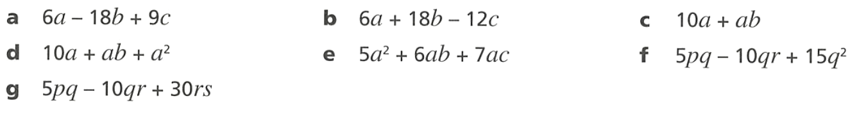  $3\left(2a-6b+3c\right)$ | $6\left(a+3b-2c\right)$ | $a\left(10+b\right)$
$a(10+b+a)$ | $a\left(5a+6b+7c\right)$ | $5q\left(p-2r+3q\right)$

- Factorise these expressions.
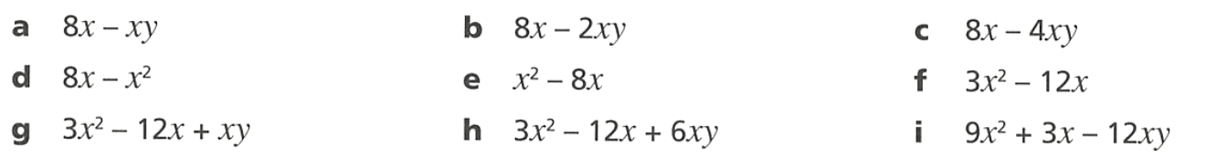  $x\left(8-y\right)$ | $2x\left(4-y\right)$ | $4x\left(2-y\right)$
$x\left(8-x\right)$ | $x\left(x-8\right)$ | $3x\left(x-4\right)$
$x\left(3x-12+y\right)$ | $3x\left(x-4+2y\right)$ | $3x\left(3x+1-4y\right)$

- Find the perimeters of these shapes and factorise your answer.
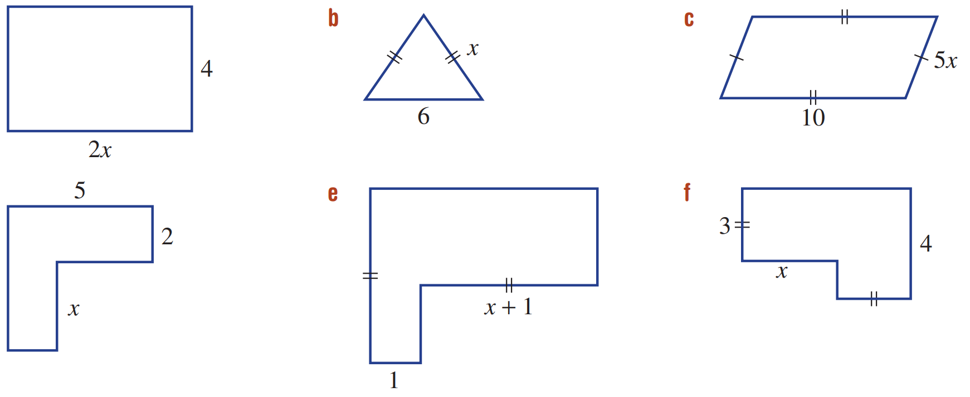  $2\left(2x+4\right)$ | $2\left(x+3\right)$ | $10\left(x+2\right)$
$2\left(7+x\right)$ | $2\left(2x+3\right)$ | $2\left(x+7\right)$

Mastery

- If $x=5$, work out the value of $2x^{2}-4x$  $30$ | - Factorise $2x^{2}-4x$  $2x\left(x-2\right)$
- Determine the value of $x$ in this equation $2x-4=10$  $x=7$ | - Expand $2x(x+2)$  $2x^{2}+4x$

- NAPLAN C
A rectangle has an area of $9a^{2}-6a.$
By factorising the expression, find the width of the rectangle if the length is $3a$.

$3a-2$
- NAPLAN C
A rectangle has an area of $2pq^{2}+4p^{2}q$.
Find the length of the rectangle if the width is $2pq$.

$q+2p$
- The expression for the area of a rectangle is $(4x^{2}+8x)$.
Find an expression for its width if the length is $(x+2)$.

$4x$
- Factorise the following expressions.
- $3a^{2}+9a+12$  $3\left(a^{2}+3a+4\right)$ | - $5z^{2}-10z+zy$  $z\left(5z-10+y\right)$
- $x^{2}-2xy+x^{2}y$  $x\left(x-2y+xy\right)$ | - $4by-2b+6b^{2}$  $2b\left(2y-1+3b\right)$
- $-12xy-8yz-20xyz$  $-4y\left(3x+2z+5xz\right)$ | - $3ab+4ab^{2}+6a^{2}b$  $ab\left(3+4b+6a\right)$
- These factorisations are incomplete. Complete the factorisation.
- $2\left(3x+9\right)$  $6\left(x+3\right)$ | - $7(4x+12y)$  $28\left(x+3y\right)$ | - $x(y+2xy)$  $$xy\left(1+2x\right)$$
- $2\left(6x+9\right)$  $6\left(2x+3\right)$ | - $3x(16zy+12y)$  $12xy\left(4z+3\right)$ | - $12x(x^{2}+xy)$  $12x^{2}\left(x+y\right)$

- NAPLAN C
Fully factorise $24p^{2}qr^{3}+18p^{3}q^{2}+6p^{2}qr^{2}$

$6p^{2}q\left(4r^{3}+3pq+r^{2}\right)$
- NAPLAN C
Fully factorise $2mn^{2}+6m^{2}n-8mn$.

$2mn\left(n+3m-4\right)$
- Rosie factorised $16xyz+24xn=4\left(4xyz+6xn\right)$.
  - Explain why she is not fully correct.

The terms in the brackets share common factors.
  - Charlotte says it should have been $8\left(2xyz+3xn\right)$. Explain why she is not fully correct.

The terms in the brackets still share a common factor of $x$.
- In senior years, it is often necessary to factorise out a fraction. Complete the following:
- $\frac{x}{2}+\frac{y}{2}$  $=\frac{1}{2}\left( \right)$  $$\frac{1}{2}\left(x+y\right)$$ | - $\frac{3a}{4}-\frac{3b}{4}$  $$\frac{3}{4}\left(a-b\right)$$ | - $\frac{2p}{3}-\frac{2q}{3}$  $$\frac{2}{3}\left(p-q\right)$$
- $\frac{x^{2}}{3}+\frac{2x}{3}$  $$\frac{x}{3}\left(x+2\right)$$ | - $\frac{3ab}{5}-\frac{2b}{5}$  $$\frac{b}{5}\left(3a-2\right)$$ | - $\frac{5p^{2}q}{8}-\frac{3pq}{8}$  $$\frac{pq}{8}\left(5p-3\right)$$

- Sienna factorised $\frac{5x}{3}+ \frac{5y}{6}$ as $\frac{5}{6}\left(2x+y\right)$
  - By expanding, show that she is correct.

  - Hence factorise these expressions; there should be no fractions inside brackets.
- $\frac{x}{2}+\frac{y}{4}$  $$\frac{1}{4}\left(2x+y\right)$$ | - $\frac{3a}{4}-\frac{b}{2}$  $$\frac{1}{4}\left(3a-2b\right)$$ | - $\frac{2p}{3}-\frac{q}{6}$  $$\frac{1}{6}\left(4p-q\right)$$
- $\frac{3x}{8}+\frac{y}{4}$  $$\frac{1}{8}\left(3x+2y\right)$$ | - $\frac{xy^{2}}{5}+\frac{xy}{10}$  $$\frac{xy}{5}\left(y+2\right)$$ | - $\frac{5c^{3}}{9}-\frac{cd}{3}$  $$\frac{c}{9}\left(5c^{2}-3d\right)$$
- Find the value of $m$ if:
$$\left(x+3\right)\left(m-2\right)=-\frac{5x}{2}-\frac{15}{2}$$

$$-\frac{5x}{2}-\frac{15}{2}=-\frac{5}{2}\left(x+3\right)$$
$$So, m-2=-\frac{5}{2}$$
$$x=-\frac{1}{2}$$
- Find the value of $k$ in each equation.
- $2x(x + 3) + kx(x - 1) = 5x² + 4x$  $$2x(x + 3) + kx(x - 1) = 5x² + 4x$$  $$2x² + 6x + kx² - kx = 5x² + 4x$$  $$(2 + k)x² + (6 - k)x = 5x² + 4x$$  $$Comparing x² coefficients: 2 + k = 5 → k = 3$$ | - $ka(a - 2) + 3a(a + 4) = 7a² + 6a$  $$ka(a - 2) + 3a(a + 4) = 7a² + 6a$$  $$ka² - 2ka + 3a² + 12a = 7a² + 6a$$  $$(k + 3)a² + (12 - 2k)a = 7a² + 6a$$  $$Comparing a² coefficients: k + 3 = 7 → k = 4$$

